Supporting Information for
Nickel catalyst with asymmetric steric hindrance for ethylene polymerization

Contents
1.Experimental Section 2
1.1 General Considerations 2
1.2 Procedure for the Synthesis of Ligands L1-L2 2
1.3 Procedure for the Synthesis of Nickel Complexes Ni1-Ni3 3
1.4 A general procedure for the homopolymerization of ethylene 3
1.5 Mechanical performance testing 3
2. Spectra Data 4
2.1. ¹H and ¹³C NMR of the Synthetic Compounds 4
2.2 NMR Spectra of Ligands L1–L2 5
2.3 NMR Spectra of the Polyethylenes 7
2.3 DSC GPC of Polymer 13
2.4 GPC of Polymer 20

1.Experimental Section

1.1 General Considerations
Unless otherwise specified, all operations are carried out in dry nitrogen atmosphere or in glove box using standard schlenk technology. The deuterated solvent used for nuclear magnetic resonance spectrum analysis is dried and distilled before use. Unless otherwise specified, ¹H and ¹³C NMR spectra were recorded on the Bruker AscendTm 400 MHz spectrometer at ambient temperature. The chemical shifts of ¹H and ¹³C NMR spectra are related to tetramethylsilane. Elemental analysis was conducted by the Analysis Center of China University of Science and Technology. The molecular weight and molecular weight distribution of (co) polymer were analyzed by gel permeation chromatography (GPC) at 150 °C on PL-GPC 220 high temperature chromatograph. The high temperature chromatograph is equipped with three detection arrays, including differential refractive index detector (RI), two angular light scattering detectors (LS) and four-bridge capillary viscometers. The system was calibrated by polystyrene standard, and the linear polyethylene chromatogram was calibrated by Rudin Mark - Houwink parameter universal calibration: polystyrene × 10⁻² cm³/g k = 1.75, r = 0.67, and polyethylene × 10⁻² cm³/g k = 5.90, r = 0.69. Differential scanning calorimetry (DSC) is performed by DSC Q20 of TA Instruments. Quickly heat it to 150 ℃ and keep it for 5 minutes to eliminate the thermal history, then cool it to 40 ℃ at the rate of 10 K/min, and finally reheat it to 150 °C at the same rate with nitrogen flow (50 mL/min). The maximum absorption point (heating scanning) is taken as the melting point temperature (T_{m}). Toluene, n-hexane, n-heptane, CDCl₃ and CH₂Cl₂ were purified on four molecular sieves or CaH₂. All other reagents were obtained from commercial sources.

1.2 Procedure for the Synthesis of Ligands L1-L2
Synthesis of L1: ZnCl₂(4.5 mmol) and acenaphthenequinone (0.36 g, 2 mmol) were suspended in glacial acetic acid (6 mL). A1(4 mmol) was added, and the reaction mixture was refluxed under stirring for 5 hours. The solution was allowed to cool to room temperature, and a bright orange-red solid precipitated. The solid was separated by filtration and washed with acetic acid (3 × 5mL) and diethyl ether (5 × 5 mL), to remove remaining acetic acid. Drying under vacuum gave bright orange-red, poorly soluble solid. Then the zinc was removed from the zinc diimine complex. The product of the previous step was suspended in methylene chloride (24 mL), and a solution of potassium oxalate (4.5 mmol) in water (2 mL) was added. The reaction mixture was stirred vigorously for overnight. The two phases were separated, and the organic layer was washed with water (3 × 10 mL) and dried with MgSO₄. After filtration the solvent was removed under vacuum to afford the product as an yellow powder(Yield: 0.63 g, 27%). ¹H NMR (400 MHz, CDCl₃, ppm): δ 7.42 (dd, J = 34.8, 7.6 Hz, 2H), 7.04 – 6.60 (m, 12H), 6.28 (t, J = 7.0 Hz, 3H), 6.19 – 6.02 (m, 3H), 4.25 (t, J = 17.8 Hz, 2H), 3.85 (d, J = 11.4 Hz, 6H), 2.27 – 2.02 (m, 6H), 1.45 (dd, J = 36.1, 6.8 Hz, 6H). ¹³C NMR (101 MHz, CDCl₃) δ 163.19(C=N), 156.10, 145.96, 142.52, 139.69, 134.81, 129.62, 128.89, 127.99, 127.88, 127.82, 127.68, 127.52, 127.30, 126.98, 125.83, 124.64, 122.12, 113.01, 110.69, 77.42, 77.10, 76.78, 55.45(-OMe), 41.14(-CH(CH₃)-), 22.18(-CH₃), 18.35(-CH₃). Calcd for: C₄₆H₄₄N₂O₂: C,84.11; H,6.75; N,4.26; Found: C, 84.04; H, 6.41; N, 4.46.
Synthesis of L2: Using the same procedure as for the synthesis of L1 was obtained as yellow powder(Yield: 1.13 g, 45%).¹H NMR (400 MHz, CDCl₃) δ 7.59 – 7.52 (m, 2H), 7.19 (d, J = 2.7 Hz, 2H), 7.06 (dt, J = 8.3, 5.7 Hz, 2H), 6.85 – 6.76 (m, 6H), 6.31 – 6.23 (m, 2H), 6.13 – 6.01 (m, 4H), 5.75 – 5.66 (m, 2H), 3.97 – 3.91 (m, 6H), 2.29 (d, J = 12.7 Hz, 6H), 1.93 (d, J = 11.3 Hz, 6H), 1.58 – 1.48 (m, 6H). ¹³C NMR (101 MHz, CDCl₃) δ 161.62, 155.47, 148.37, 142.94, 140.03, 138.02, 129.56, 129.50, 127.64, 126.80, 126.45, 126.43, 125.90, 123.40, 122.07, 112.59, 111.99, 77.38, 77.06, 76.74, 55.50, 42.53, 34.01, 23.59, 19.14. Clacd for C₄₄H₄₀N₂O₂: C, 84.04; H, 6.41; N, 4.46; Found: C, 84.11; H, 6.75; N, 4.26

1.3 Procedure for the Synthesis of Nickel Complexes Ni1-Ni3
Synthesis of Complexes Ni1: It were synthesized by the reaction of 1 equiv of (DME)NiBr₂ with the corresponding ligands in methylene chloride. The corresponding ligand (0.3 mmol) was added in 10 mL of methylene chloride in a Schlenk tube under a nitrogen atmosphere. A suspension of (DME)NiBr₂ (0.3 mmol) in CH₂Cl₂ (10 mL) was added to the above solution. The resulting mixture was stirred at room temperature for 24 hours. The solvent was evaporated under reduced pressure to afford a solid. The product was washed with 4 × 5 mL diethyl ether and dried under vacuum. The single crystal can be obtained by diffusion from layering hexane on to the CH₂Cl₂ solution at room temperature, Ni1. Brown solid (Yield: 0.21 g, 82%). Clacd for C₄₆H₄₄Br₂N₂NiO₂: C, 62.12; H, 4.07; N, 3.20; Found: C, 62.37; H, 4.76; N, 3.31.
Synthesis of Complexes Ni2: Using the same procedure as for the synthesis of Ni1 was obtained as brown solid. (Yield: 0.22 g, 85%). Clacd for C₄₄H₄₀Br₂N₂NiO₂: C, 62.37; H, 4.76; N, 3.31; Found: C, 63.12; H, 5.07; N, 3.20.
Synthesis of Complexes Ni3: Using the same procedure as for the synthesis of Ni1 was obtained as brown solid. (Yield: 0.17 g, 88%). Clacd for C₂₈H₂₄Br₂N₂NiO₂: C, 52.63; H, 3.79; N, 4.38; Found: C, 52.69; H, 3.82; N, 4.29.

1.4 A general procedure for the homopolymerization of ethylene
In a typical experiment, a 350 mL glass pressure reactor connected with a high pressure gas line was firstly dried at 90 °C under vacuum for at least 1 h. The reactor was then adjusted to the desired polymerization temperature. 20 mL of toluene and the desired amount Et₂AlCl was added to the reactor under N₂ atmosphere, then the desired amount of catalyst in 2 mL of CH₂Cl₂ was injected into the polymerization system via syringe. With a rapid stirring, the reactor was pressurized and maintained at 8 atm of ethylene. After 10 mintues, the pressure reactor was vented and the polymer was precipitated in ethanol, filtered and dried at 50°C for at least 24 h under vacuum.

1.5 Mechanical performance testing
Stress/strain experiments were performed at room temperature at 10 mm/min using a universal testing machine, Suns UTM 2502 from Shenzhen Suns Technology Company. At least three specimens of each polymer were tested. Each polymer was melt-pressed at about 150 °C, 5 MPa for 5 min to obtain the test specimen. The dumbbell shaped test specimens had the following dimensions: gauge length, 28 mm; width, 2 mm; and thickness, about 1 mm.

2. Spectra Data

2.1. ¹H and ¹³C NMR of the Synthetic Compounds
Figure S1. ¹H NMR spectrum (400 MHz, CDCl₃) of A1.
Figure S2. ¹³C NMR spectrum (400 MHz, CDCl₃) of A1.
Figure S3. ¹H NMR spectrum (400 MHz, CDCl₃) of A2.

Figure S4. ¹³C NMR spectrum (400 MHz, CDCl₃) of A2.

2.2 NMR Spectra of Ligands L1–L2

Figure S5. ¹H NMR spectrum in CDCl₃ of L1.

Figure S6. ¹³C NMR spectrum in CDCl₃ of L1.
Figure S7. ¹H NMR spectrum in CDCl₃ of L2.

Figure S8. ¹³C NMR spectrum in CDCl₃ of L2.

2.3 NMR Spectra of the Polyethylenes

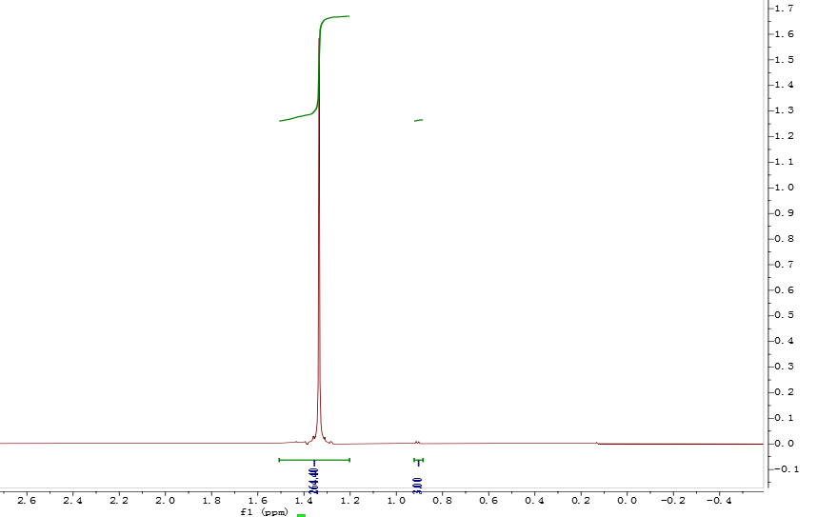 Figure S9. ¹H NMR spectrum of the polymer from table 1, entry 1(CDCl₂CDCl₂, 120 °C).

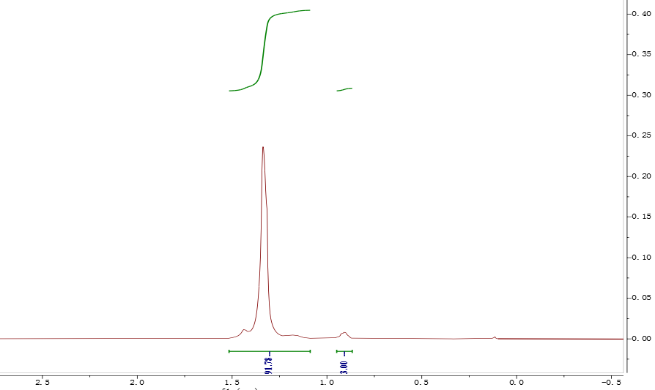
Figure S10. ¹H NMR spectrum of the polymer from table 1, entry 2(CDCl₂CDCl₂, 120 °C).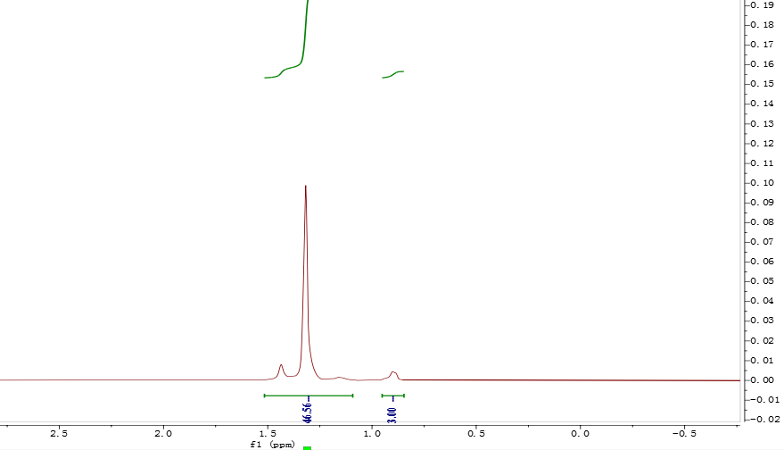
Figure S11. ¹H NMR spectrum of the polymer from table 1, entry 3(CDCl₂CDCl₂, 120 °C).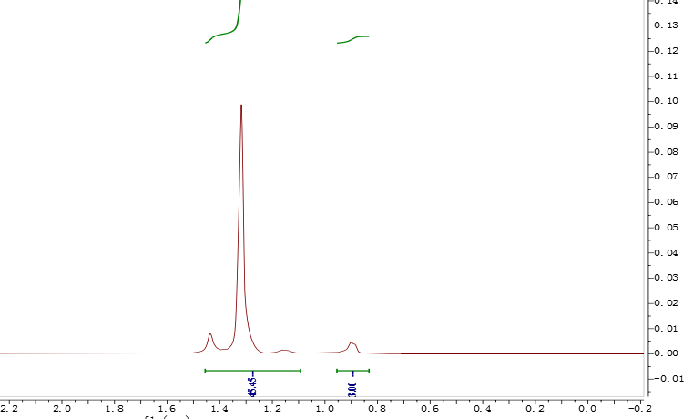
Figure S12. ¹H NMR spectrum of the polymer from table 1, entry 4(CDCl₂CDCl₂, 120 °C).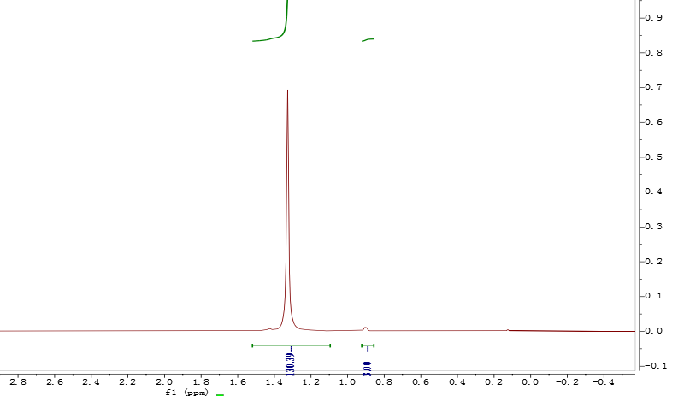
Figure S13. ¹H NMR spectrum of the polymer from table 1, entry 5(CDCl₂CDCl₂, 120 °C).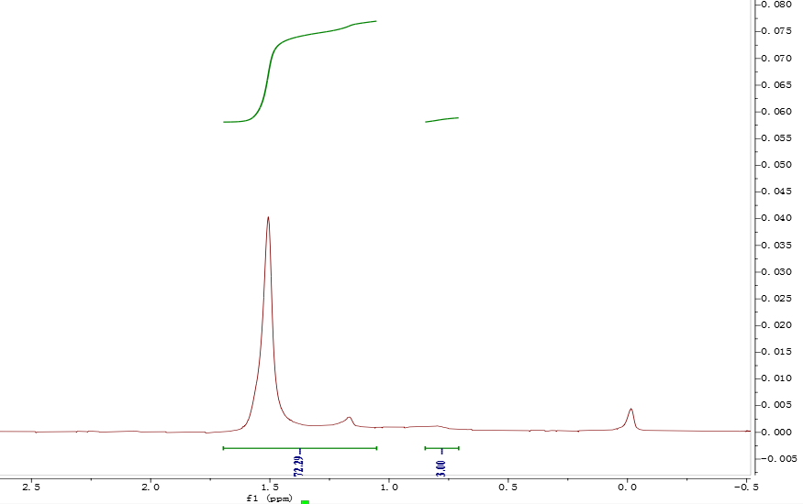
Figure S14. ¹H NMR spectrum of the polymer from table 1, entry 6(CDCl₂CDCl₂, 120 °C).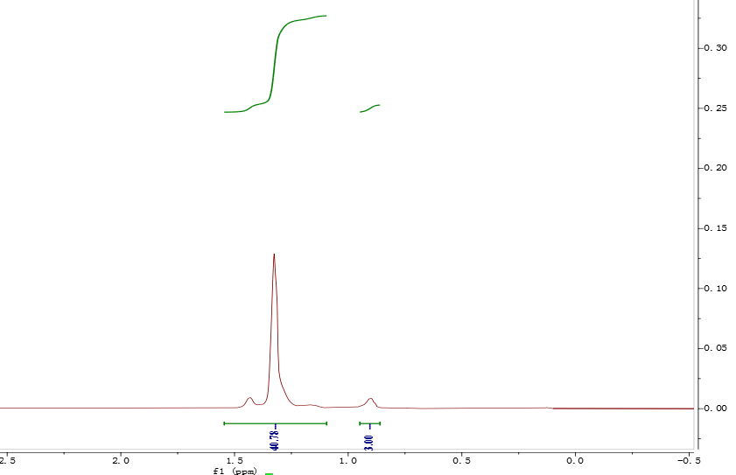
Figure S15. ¹H NMR spectrum of the polymer from table 1, entry 7(CDCl₂CDCl₂, 120 °C).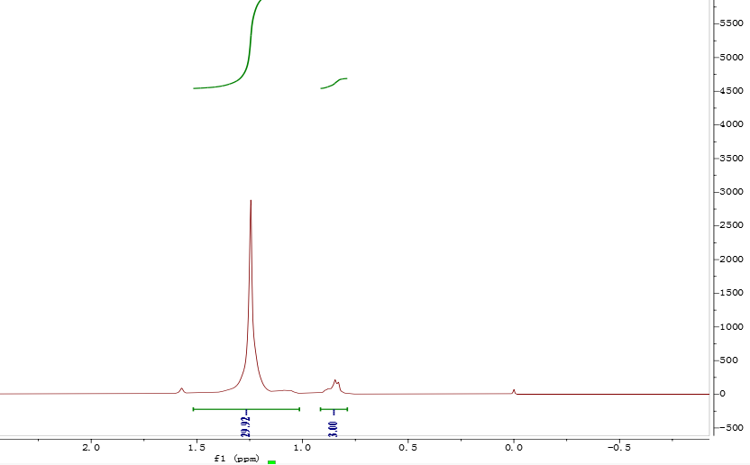
Figure S16. ¹H NMR spectrum of the polymer from table 1, entry 8(CDCl₂CDCl₂, 120 °C).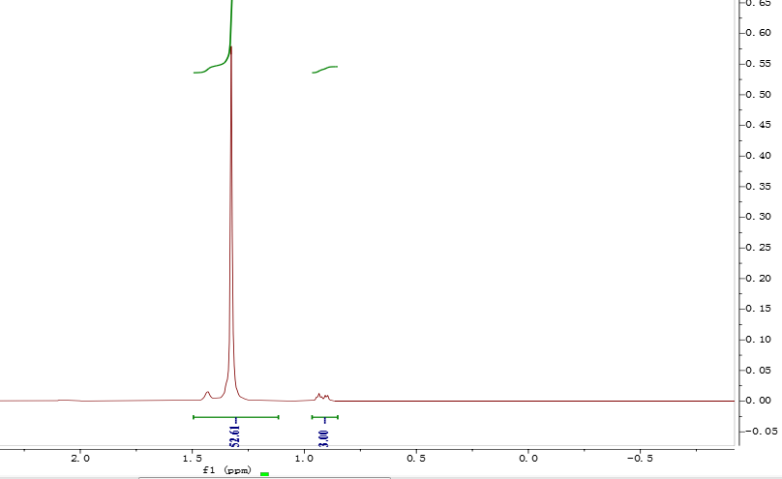
Figure S17. ¹H NMR spectrum of the polymer from table 1, entry 9(CDCl₂CDCl₂, 120 °C).

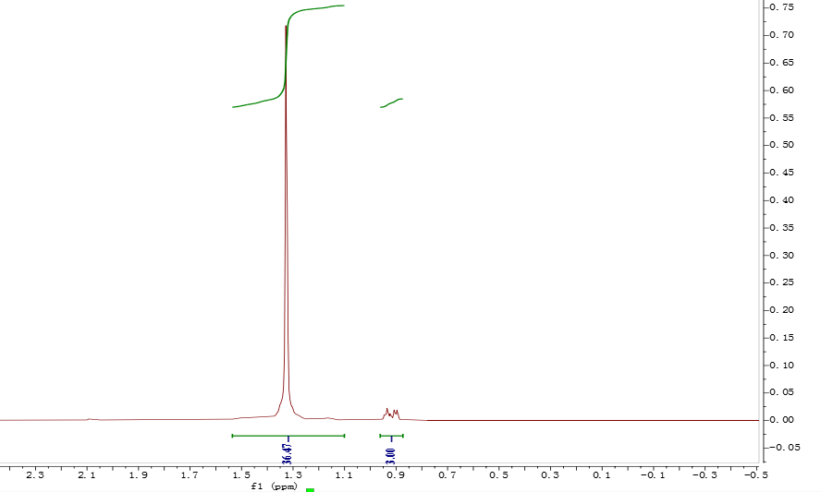
Figure S18. ¹H NMR spectrum of the polymer from table 1, entry 10(CDCl₂CDCl₂, 120 °C).
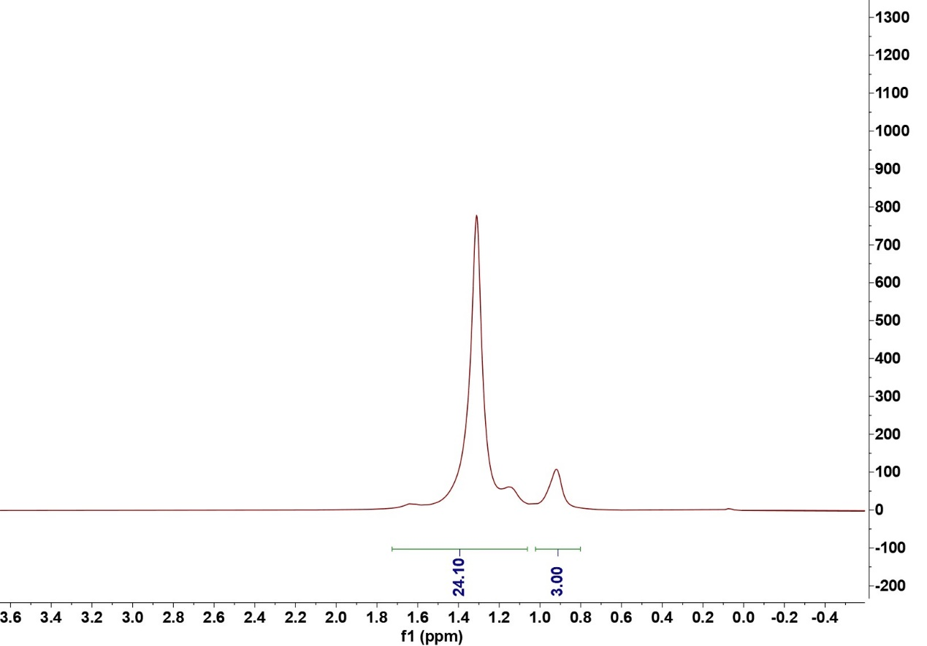
Figure S19. ¹H NMR spectrum of the polymer from table 1, entry 11(CDCl₂CDCl₂, 120 °C).
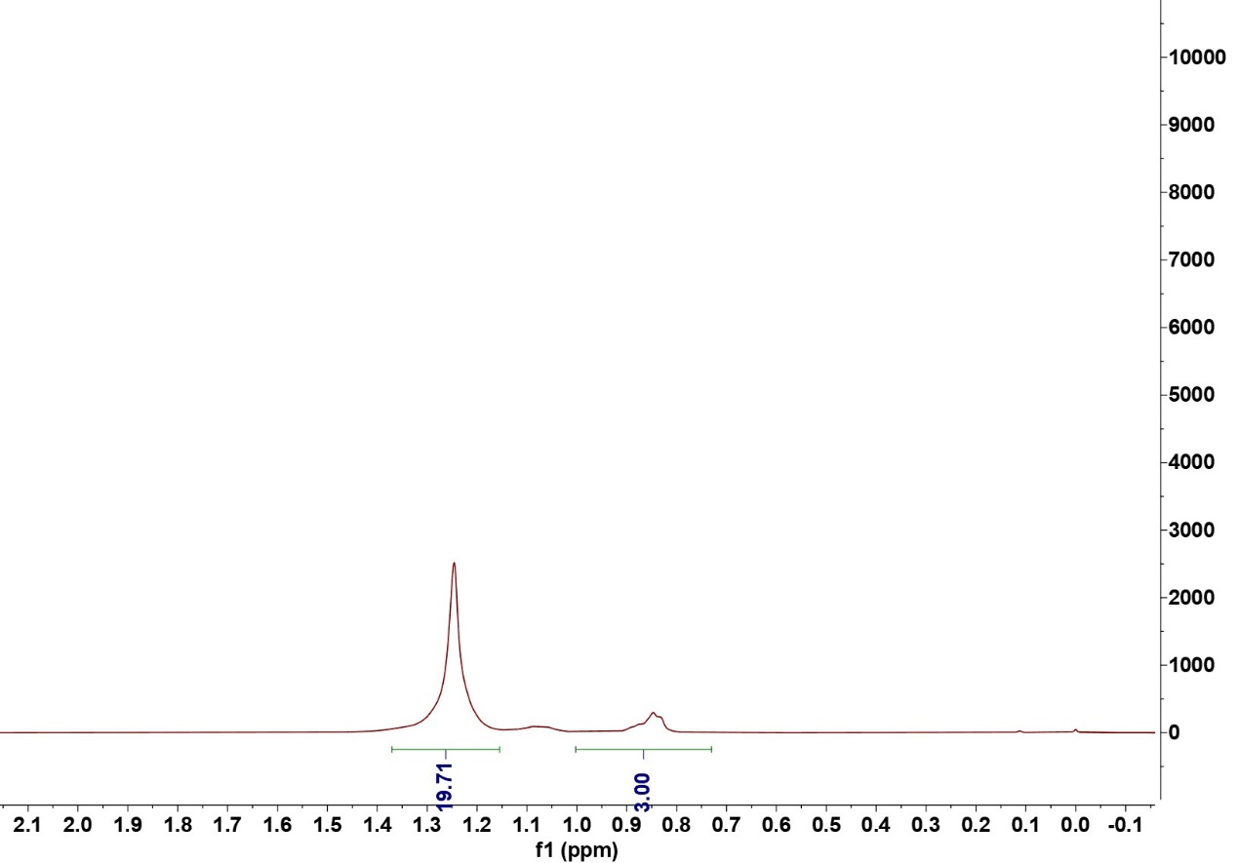
Figure S20. ¹H NMR spectrum of the polymer from table 1, entry 12(CDCl₂CDCl₂, 120 °C).

2.3 DSC GPC of Polymer

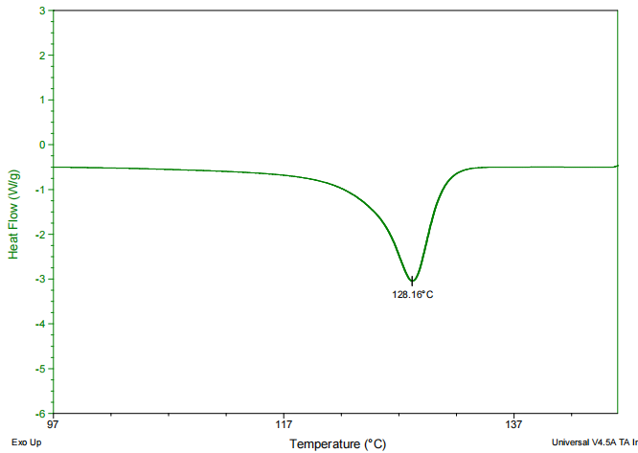
Figure S21. DSC of the polymer from table 1, entry 1.

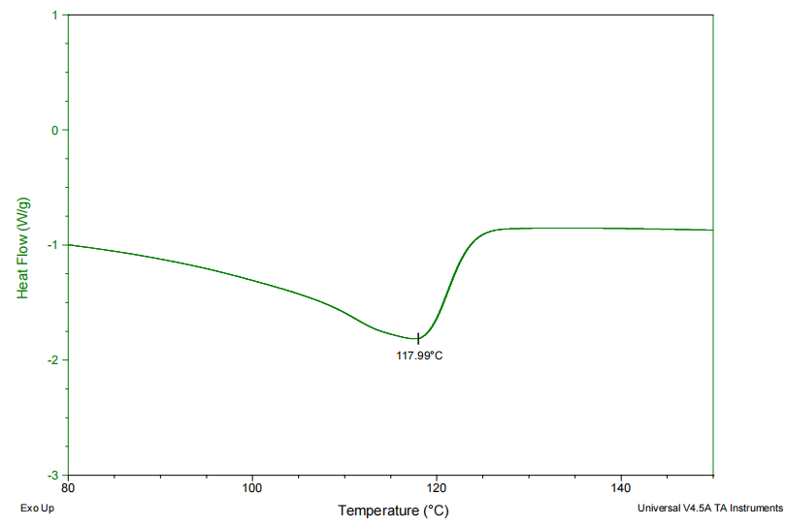
Figure S22. DSC of the polymer from table 1, entry 2.

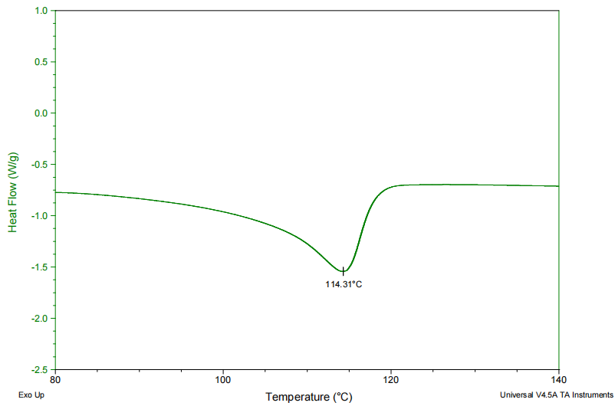
Figure S23. DSC of the polymer from table 1, entry 3.

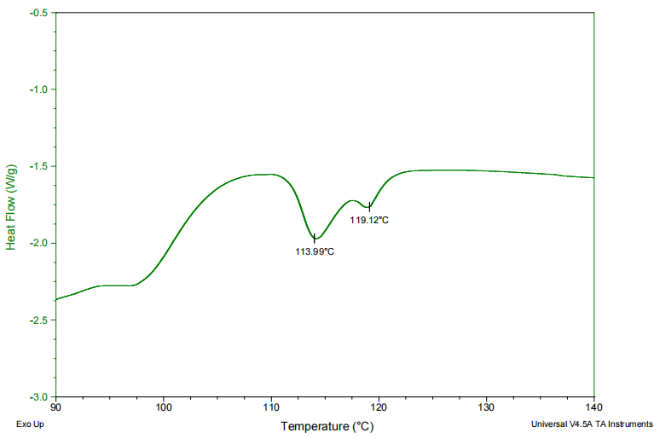
Figure S24. DSC of the polymer from table 1, entry 4.

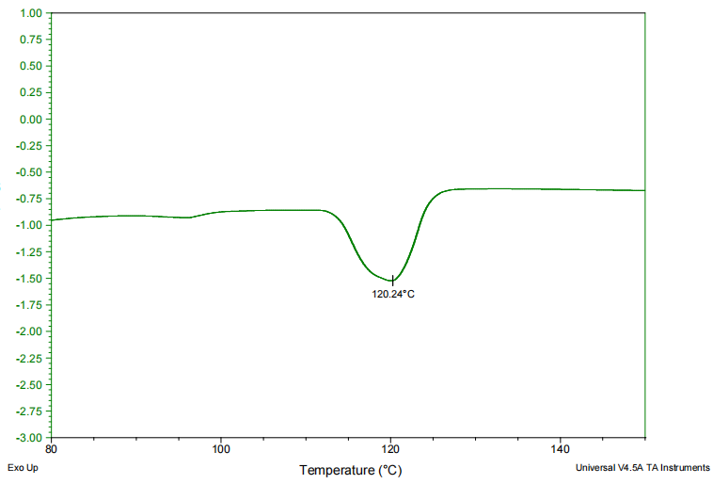
Figure S25. DSC of the polymer from table 1, entry 5.

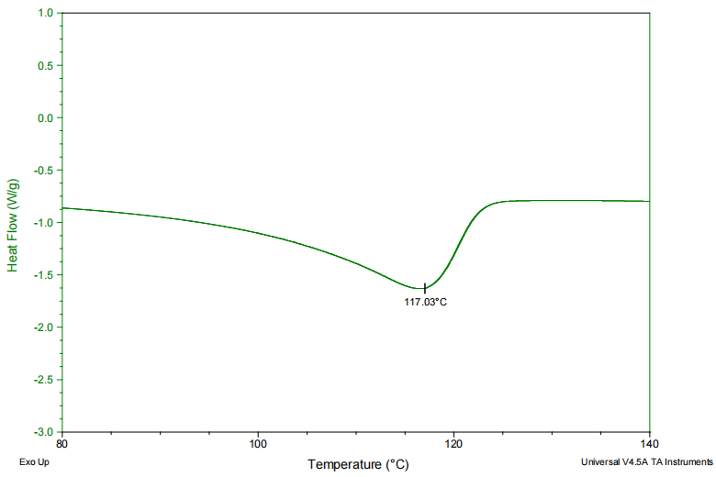
Figure S26. DSC of the polymer from table 1, entry 6
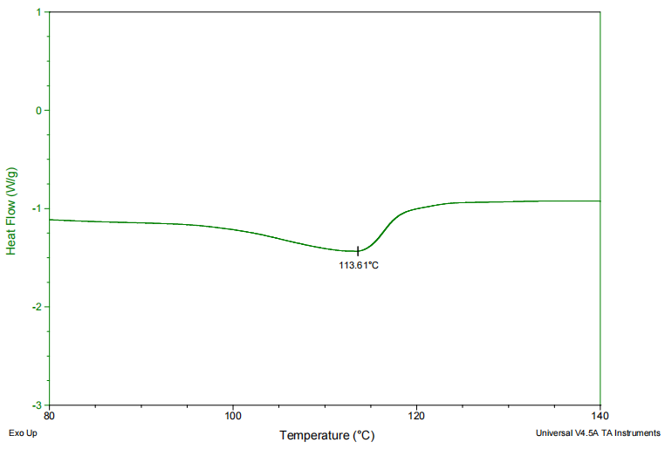
Figure S27. DSC of the polymer from table 1, entry 7

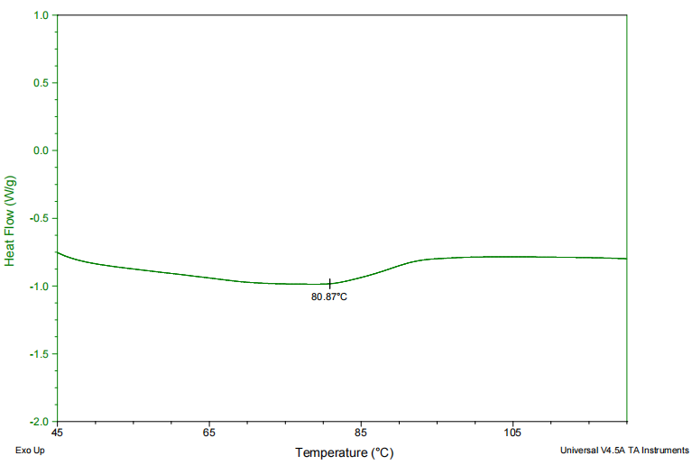
Figure S28. DSC of the polymer from table 1, entry 8.

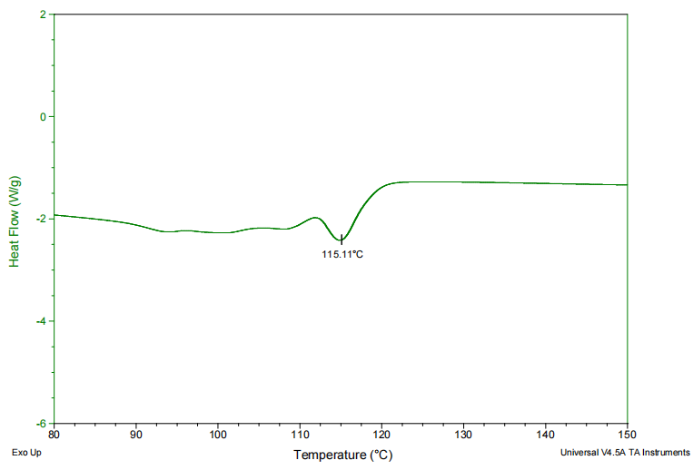
Figure S29. DSC of the polymer from table 1, entry 9.

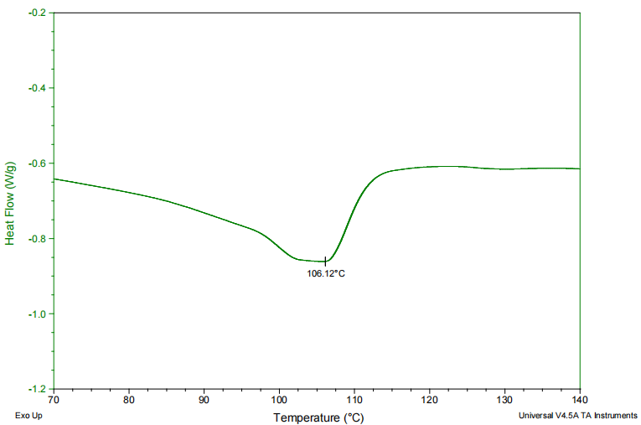
Figure S30. DSC of the polymer from table 1, entry 10.

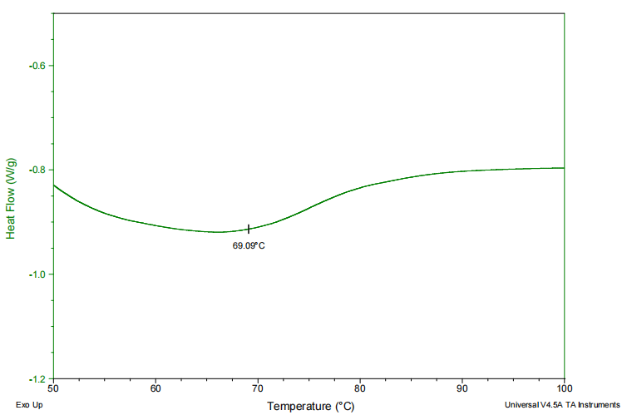
Figure S31. DSC of the polymer from table 1, entry 11.

2.4 GPC of Polymer
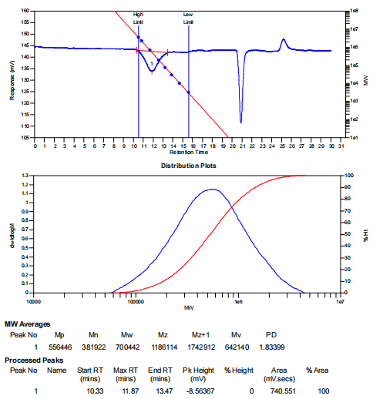
Figure S32. GPC of the polymer from table 1, entry 1.

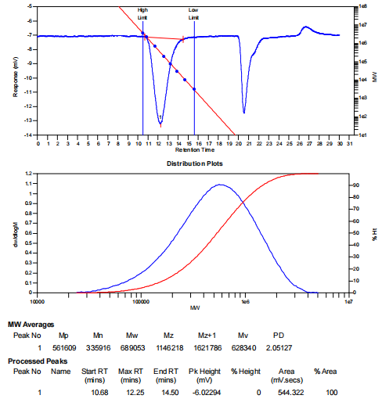
Figure S33. DSC of the polymer from table 1, entry 2.

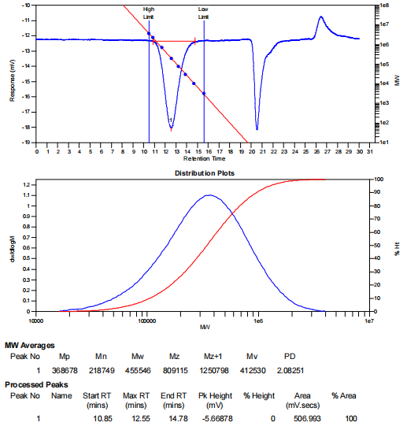
Figure S34. DSC of the polymer from table 1, entry 3.

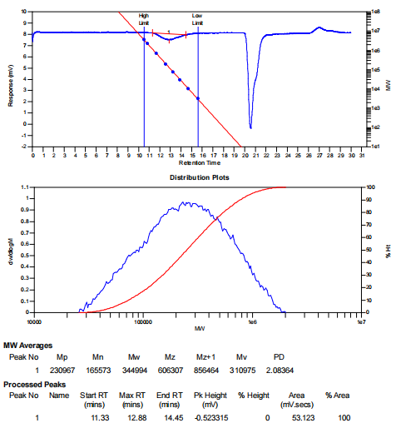
Figure S35. DSC of the polymer from table 1, entry 4.
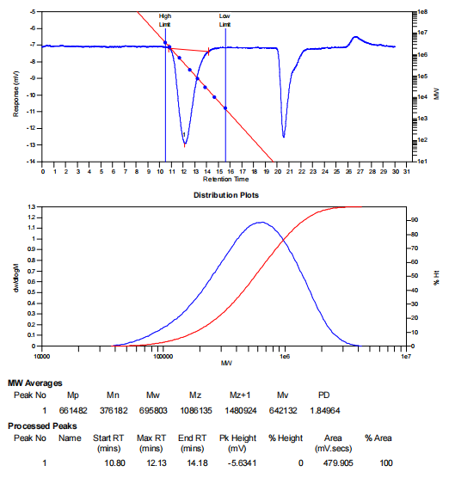
Figure S36. GPC of the polymer from table 1, entry 5

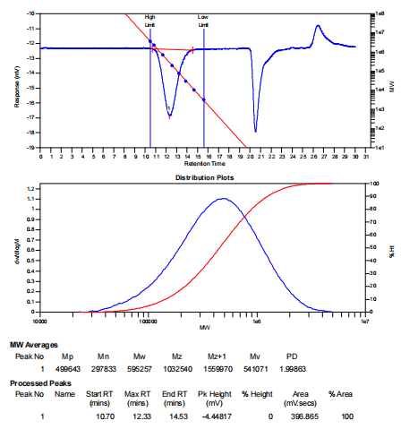
Figure S37. GPC of the polymer from table 1, entry 6

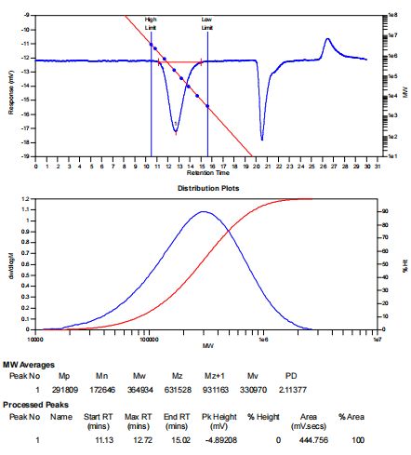
Figure S38. GPC of the polymer from table 1, entry 7

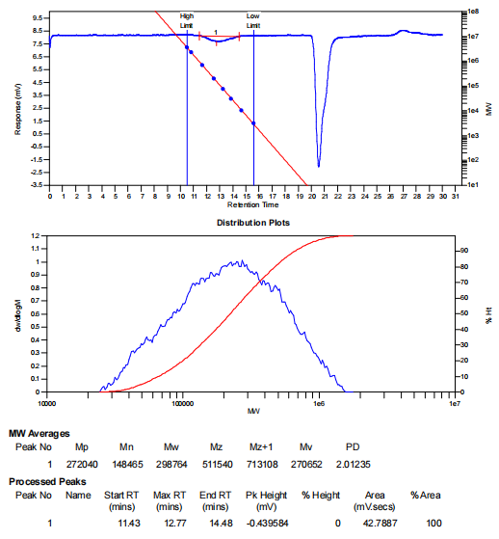
Figure S39. GPC of the polymer from table 1, entry 8

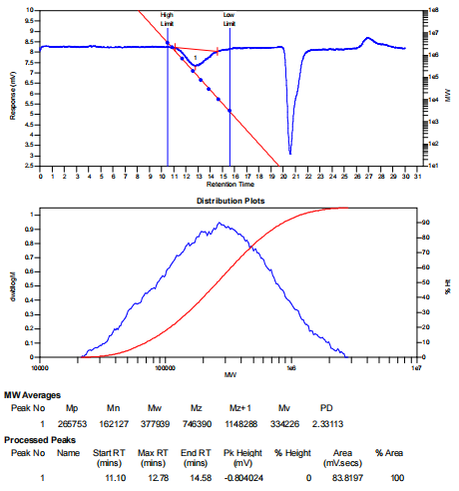
Figure S40. GPC of the polymer from table 1, entry 9

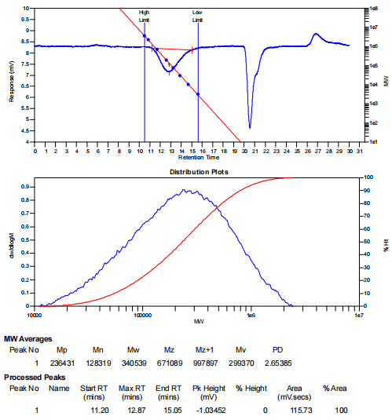
Figure S41. GPC of the polymer from table 1, entry 10

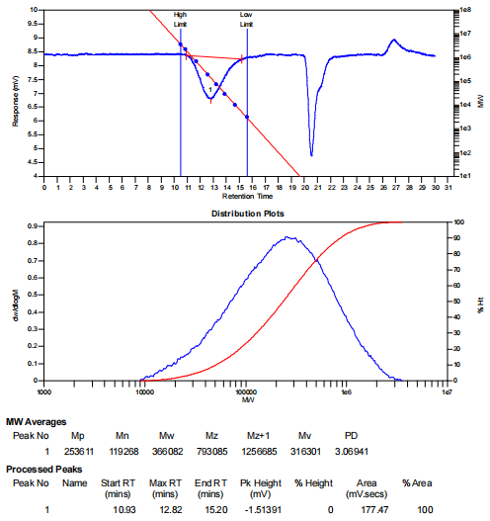
Figure S42. GPC of the polymer from table 1, entry 11

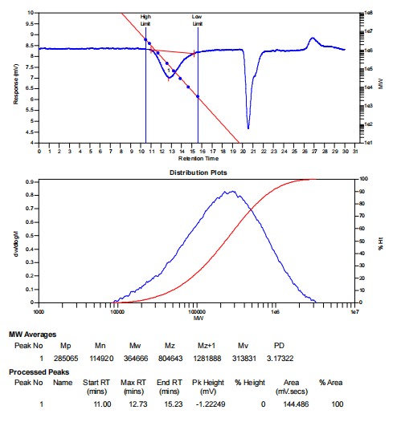
Figure S43. GPC of the polymer from table 1, entry 12

